**TUGAS KELOMPOK BASIS DATA**

**LAPORAN TAHAP I**

**IMPLEMENTASI BASIS DATA**



**Disusun oleh:**

Arri Kurniawan 1606954735

Budi Indrawan 1606954754

Fadly Muhammad Ridho 1606954792

Riyandi Eko Pambudi 1406649403

**Program Studi S1 Ekstensi Sistem Informasi**

**Fakultas Ilmu Komputer**

**Universitas Indonesia**

**2017**

1. **DDL script table**

CREATE SCHEMA SIRIMA;

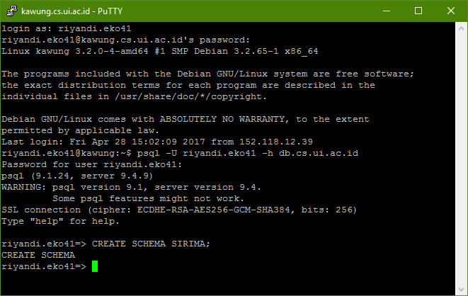

SET search_path to SIRIMA;

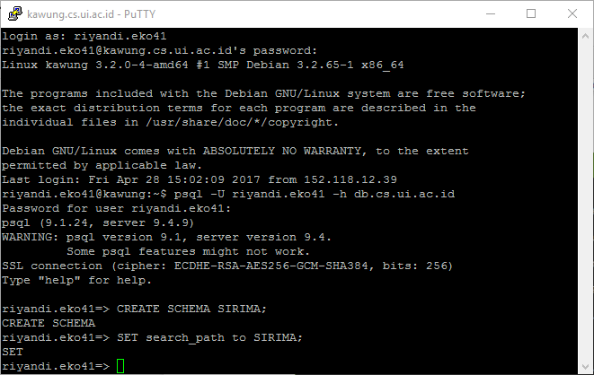

CREATE TABLE AKUN (

username VARCHAR(50) NOT NULL,

role BOOLEAN NOT NULL,

password VARCHAR(20) NOT NULL,

PRIMARY KEY (username)

);

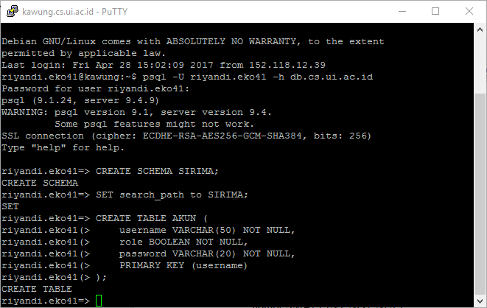

CREATE TABLE PERIODE_PENERIMAAN (

nomor SMALLINT NOT NULL,

tahun CHAR(4) NOT NULL,

PRIMARY KEY (nomor, tahun)

);

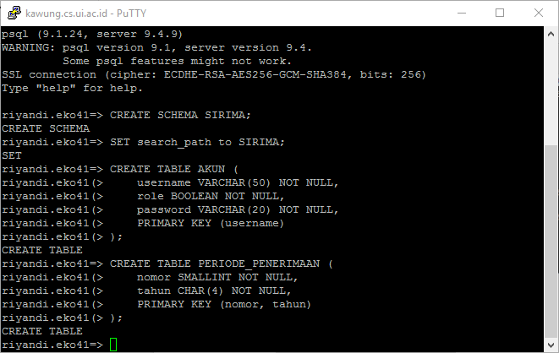

CREATE TABLE JENJANG (

nama CHAR(2) NOT NULL,

PRIMARY KEY (nama)

);

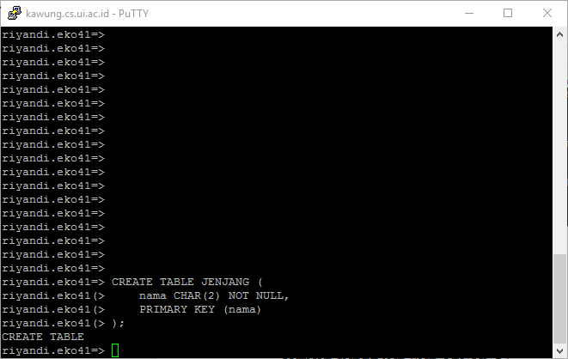

CREATE TABLE JADWAL_PENTING (

nomor SMALLINT NOT NULL,

tahun CHAR(4) NOT NULL,

jenjang CHAR(2) NOT NULL,

waktu_mulai TIMESTAMP NOT NULL,

waktu_selesai TIMESTAMP NOT NULL,

deskripsi VARCHAR(150) NOT NULL,

PRIMARY KEY (nomor, tahun, jenjang, waktu_mulai),

FOREIGN KEY (nomor, tahun) REFERENCES PERIODE_PENERIMAAN(nomor, tahun) ON UPDATE CASCADE ON DELETE CASCADE,

FOREIGN KEY (jenjang) REFERENCES JENJANG(nama) ON UPDATE CASCADE ON DELETE CASCADE

);

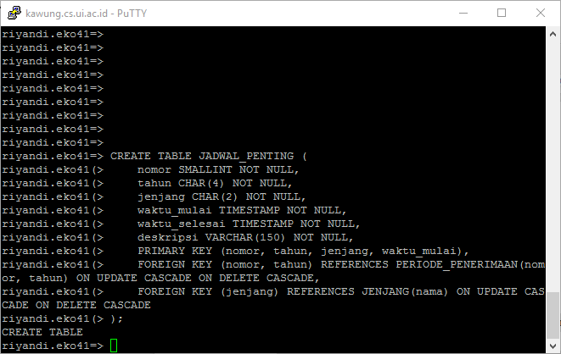

CREATE TABLE PROGRAM_STUDI (

kode SERIAL NOT NULL,

nama VARCHAR(100) NOT NULL,

jenis_kelas VARCHAR(50) NOT NULL,

nama_fakultas VARCHAR(50) NOT NULL,

jenjang CHAR(2) NOT NULL,

PRIMARY KEY (kode),

FOREIGN KEY (jenjang) REFERENCES JENJANG(nama) ON UPDATE CASCADE ON DELETE CASCADE

);

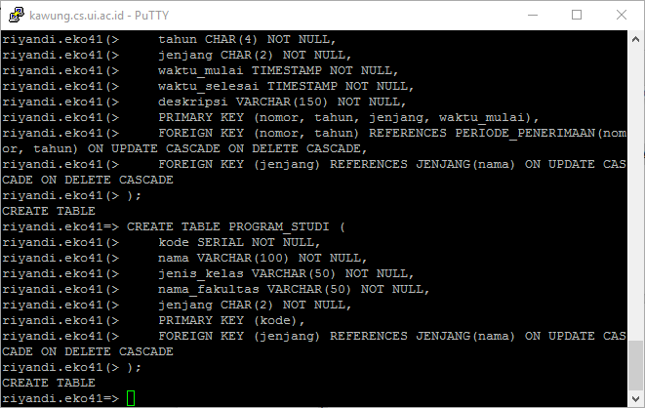

CREATE TABLE PENERIMAAN_PRODI (

nomor_periode INT NOT NULL,

tahun_periode CHAR(4) NOT NULL,

kode_prodi INT NOT NULL,

kuota INT NOT NULL,

jumlah_pelamar INT,

jumlah_diterima INT,

PRIMARY KEY (nomor_periode, tahun_periode, kode_prodi),

FOREIGN KEY (nomor_periode, tahun_periode) REFERENCES PERIODE_PENERIMAAN(nomor, tahun) ON UPDATE CASCADE ON DELETE CASCADE,

FOREIGN KEY (kode_prodi) REFERENCES PROGRAM_STUDI(kode) ON UPDATE CASCADE ON DELETE CASCADE

);

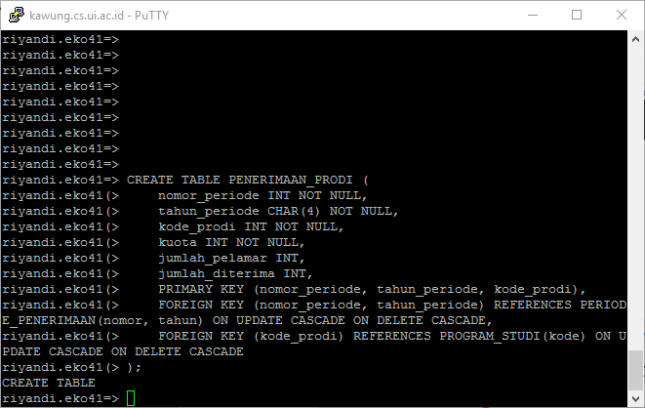

CREATE TABLE PELAMAR (

username VARCHAR(50) NOT NULL,

nama_lengkap VARCHAR(100) NOT NULL,

alamat TEXT NOT NULL,

jenis_kelamin CHAR(1) NOT NULL,

tanggal_lahir DATE NOT NULL,

no_ktp CHAR(16) NOT NULL,

email VARCHAR(100) UNIQUE NOT NULL,

PRIMARY KEY (username),

FOREIGN KEY (username) REFERENCES AKUN(username) ON UPDATE CASCADE ON DELETE CASCADE

);

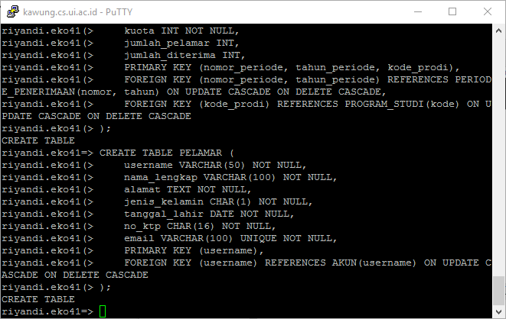

CREATE TABLE PENDAFTARAN (

id SERIAL NOT NULL,

status_lulus BOOLEAN NOT NULL DEFAULT FALSE,

status_verifikasi BOOLEAN NOT NULL DEFAULT FALSE,

npm CHAR(10) NOT NULL,

pelamar VARCHAR(50) NOT NULL,

nomor_periode SMALLINT NOT NULL,

tahun_periode CHAR(4) NOT NULL,

PRIMARY KEY (id),

FOREIGN KEY (pelamar) REFERENCES PELAMAR(username) ON UPDATE CASCADE ON DELETE CASCADE,

FOREIGN KEY (nomor_periode, tahun_periode) REFERENCES PERIODE_PENERIMAAN(nomor, tahun) ON UPDATE CASCADE ON DELETE CASCADE

);

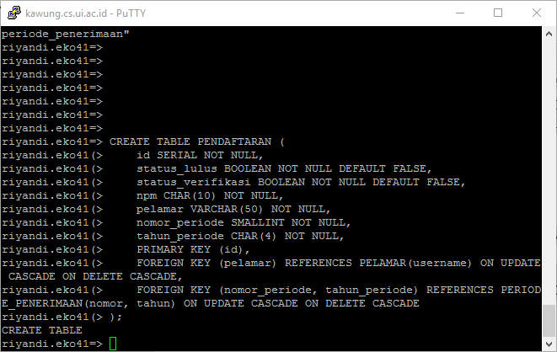

CREATE TABLE PENDAFTARAN_UUI (

id_pendaftaran INT NOT NULL,

rapot VARCHAR(100) NOT NULL,

surat_rekomendasi VARCHAR(100) NOT NULL,

asal_sekolah VARCHAR(100) NOT NULL,

jenis_sma VARCHAR(50) NOT NULL,

alamat_sekolah TEXT NOT NULL,

nisn VARCHAR(10) NOT NULL,

tgl_lulus DATE NOT NULL,

nilai_uan NUMERIC(10,2) NOT NULL,

PRIMARY KEY (id_pendaftaran),

FOREIGN KEY (id_pendaftaran) REFERENCES PENDAFTARAN(id) ON UPDATE CASCADE ON DELETE CASCADE

);

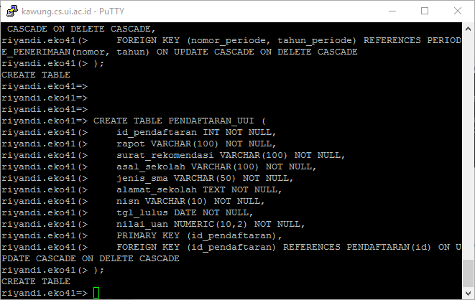

CREATE TABLE REKOMENDASI (

tgl_review DATE NOT NULL,

id_pendaftaran INT NOT NULL,

status BOOLEAN NOT NULL,

nilai INT NOT NULL,

komentar TEXT NOT NULL,

PRIMARY KEY (tgl_review, id_pendaftaran),

FOREIGN KEY (id_pendaftaran) REFERENCES PENDAFTARAN_UUI(id_pendaftaran) ON UPDATE CASCADE ON DELETE CASCADE

);

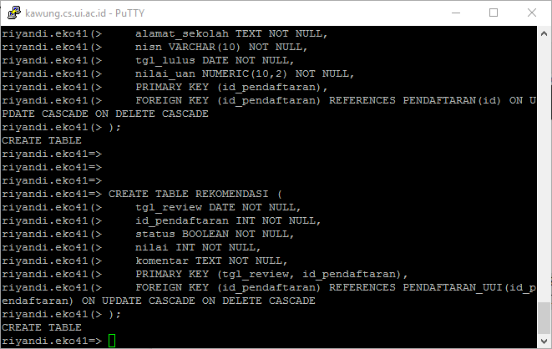

CREATE TABLE LOKASI_UJIAN (

kota VARCHAR(100) NOT NULL,

tempat VARCHAR(150) NOT NULL,

nomor_periode SMALLINT NOT NULL,

tahun_periode CHAR(4) NOT NULL,

jenjang CHAR(2) NOT NULL,

waktu_awal TIMESTAMP NOT NULL,

PRIMARY KEY (kota, tempat),

FOREIGN KEY (nomor_periode, tahun_periode, jenjang, waktu_awal) REFERENCES JADWAL_PENTING(nomor, tahun, jenjang, waktu_mulai) ON UPDATE CASCADE ON DELETE CASCADE

);

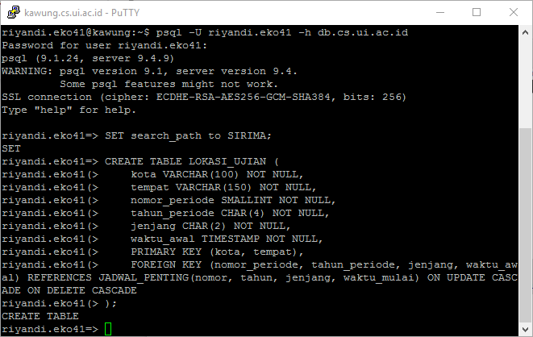

CREATE TABLE PENDAFTARAN_SEMAS (

id_pendaftaran INT NOT NULL,

status_hadir BOOLEAN NOT NULL,

nilai_ujian INT NOT NULL,

no_kartu_ujian CHAR(10) NOT NULL,

lokasi_kota VARCHAR(100) NOT NULL,

lokasi_tempat VARCHAR(150) NOT NULL,

PRIMARY KEY (id_pendaftaran),

FOREIGN KEY (id_pendaftaran) REFERENCES PENDAFTARAN(id) ON UPDATE CASCADE ON DELETE CASCADE,

FOREIGN KEY (lokasi_kota, lokasi_tempat) REFERENCES LOKASI_UJIAN(kota, tempat) ON UPDATE CASCADE ON DELETE CASCADE

);

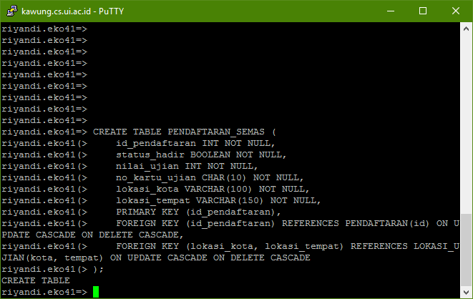

CREATE TABLE PENDAFTARAN_SEMAS_SARJANA (

id_pendaftaran INT NOT NULL,

asal_sekolah VARCHAR(100) NOT NULL,

jenis_sma VARCHAR(50) NOT NULL,

alamat_sekolah TEXT NOT NULL,

nisn VARCHAR(10) NOT NULL,

tgl_lulus DATE NOT NULL,

nilai_uan NUMERIC(10,2) NOT NULL,

PRIMARY KEY (id_pendaftaran),

FOREIGN KEY (id_pendaftaran) REFERENCES PENDAFTARAN_SEMAS(id_pendaftaran) ON UPDATE CASCADE ON DELETE CASCADE

);

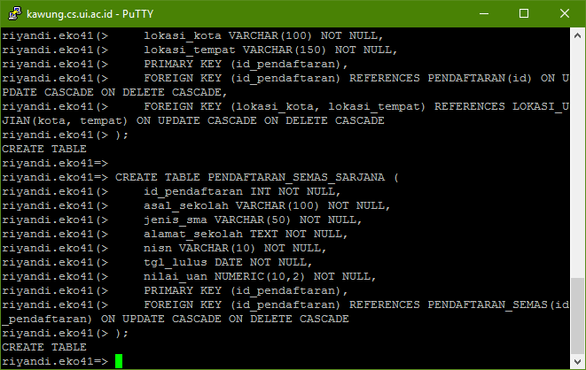

CREATE TABLE PENDAFTARAN_SEMAS_PASCASARJANA (

id_pendaftaran INT NOT NULL,

nilai_tpa INT NOT NULL,

nilai_toefl INT NOT NULL,

jenjang_terakhir CHAR(2) NOT NULL,

asal_univ VARCHAR(100) NOT NULL,

alamat_univ TEXT NOT NULL,

prodi_terakhir VARCHAR(10) NOT NULL,

nilai_ipk NUMERIC(10,2) NOT NULL,

no_ijazah VARCHAR(50) NOT NULL,

tgl_lulus DATE NOT NULL,

jenjang CHAR(2) NOT NULL,

nama_rekomender VARCHAR(100),

prop_penelitian VARCHAR(100),

PRIMARY KEY (id_pendaftaran),

FOREIGN KEY (id_pendaftaran) REFERENCES PENDAFTARAN_SEMAS(id_pendaftaran) ON UPDATE CASCADE ON DELETE CASCADE,

FOREIGN KEY (jenjang_terakhir) REFERENCES JENJANG(nama) ON UPDATE CASCADE ON DELETE CASCADE,

FOREIGN KEY (jenjang) REFERENCES JENJANG(nama) ON UPDATE CASCADE ON DELETE CASCADE

);

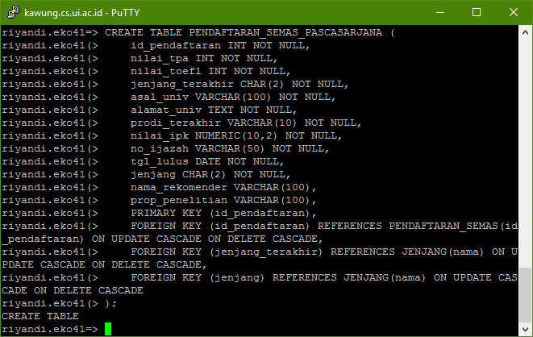

CREATE TABLE PEMBAYARAN (

id SERIAL NOT NULL,

waktu_bayar TIMESTAMP NOT NULL,

jumlah_bayar NUMERIC(10,2) NOT NULL,

id_pendaftaran INT NOT NULL,

PRIMARY KEY (id),

FOREIGN KEY (id_pendaftaran) REFERENCES PENDAFTARAN_SEMAS(id_pendaftaran) ON UPDATE CASCADE ON DELETE CASCADE

);

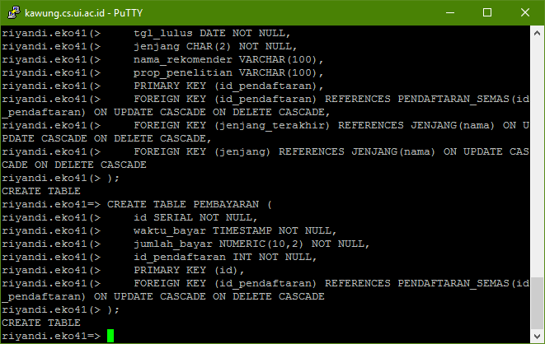

CREATE TABLE RUANG_UJIAN (

kota VARCHAR(100) NOT NULL,

tempat VARCHAR(150) NOT NULL,

id SMALLINT NOT NULL,

PRIMARY KEY (kota, tempat, id),

FOREIGN KEY (kota, tempat) REFERENCES LOKASI_UJIAN(kota, tempat) ON UPDATE CASCADE ON DELETE CASCADE

);

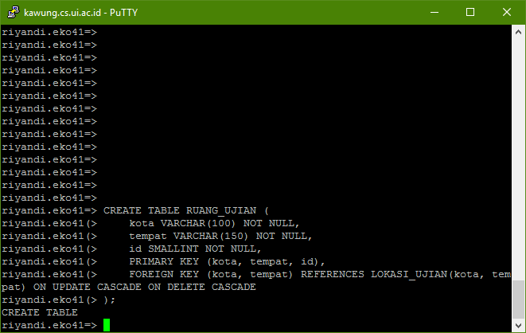

CREATE TABLE PENGAWAS (

nomor_induk VARCHAR(16) NOT NULL,

nama VARCHAR(100) NOT NULL,

no_telp TEXT NOT NULL,

lokasi_kota VARCHAR(100) NOT NULL,

lokasi_tempat VARCHAR(150) NOT NULL,

lokasi_id SMALLINT NOT NULL,

PRIMARY KEY (nomor_induk),

FOREIGN KEY (lokasi_kota, lokasi_tempat, lokasi_id) REFERENCES RUANG_UJIAN(kota, tempat, id) ON UPDATE CASCADE ON DELETE CASCADE

);

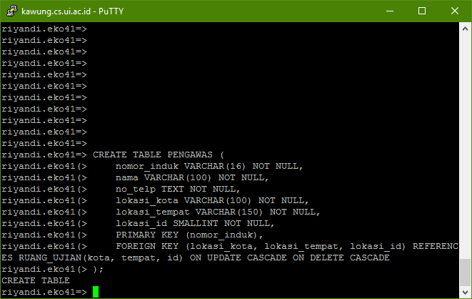

CREATE TABLE PENDAFTARAN_PRODI (

id_pendaftaran INT NOT NULL,

kode_prodi INT NOT NULL,

status_lulus BOOLEAN NOT NULL,

PRIMARY KEY (id_pendaftaran, kode_prodi),

FOREIGN KEY (id_pendaftaran) REFERENCES PENDAFTARAN(id) ON UPDATE CASCADE ON DELETE CASCADE,

FOREIGN KEY (kode_prodi) REFERENCES PROGRAM_STUDI(kode) ON UPDATE CASCADE ON DELETE CASCADE

);

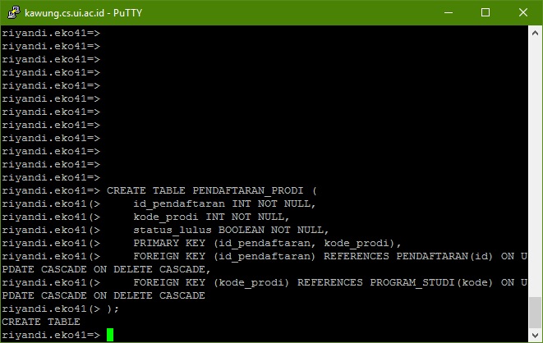

1. **DDL script trigger/stored procedure**

CREATE OR REPLACE FUNCTION hitung_pelamar()

RETURNS trigger AS

$$

BEGIN

IF (TG_OP = 'INSERT') THEN

UPDATE PENERIMAAN_PRODI PNP

SET jumlah_pelamar = (coalesce(jumlah_pelamar,0) + 1)

FROM PERIODE_PENERIMAAN PRP

JOIN PENDAFTARAN P

ON P.NOMOR_PERIODE = PRP.NOMOR

AND P.TAHUN_PERIODE = PRP.TAHUN

WHERE PRP.NOMOR = PNP.NOMOR_PERIODE

AND PRP.TAHUN = PNP.TAHUN_PERIODE

AND P.ID = NEW.ID_PENDAFTARAN

AND PNP.KODE_PRODI = NEW.kode_prodi;

ELSEIF (TG_OP = 'UPDATE') THEN

UPDATE PENERIMAAN_PRODI PNP

SET jumlah_pelamar = (coalesce(jumlah_pelamar,0) + 1)

FROM PERIODE_PENERIMAAN PRP

JOIN PENDAFTARAN P

ON P.NOMOR_PERIODE = PRP.NOMOR

AND P.TAHUN_PERIODE = PRP.TAHUN

WHERE PRP.NOMOR = PNP.NOMOR_PERIODE

AND PRP.TAHUN = PNP.TAHUN_PERIODE

AND P.ID = NEW.ID_PENDAFTARAN

AND PNP.KODE_PRODI = NEW.kode_prodi;

UPDATE PENERIMAAN_PRODI PNP

SET jumlah_pelamar = (jumlah_pelamar - 1)

FROM PERIODE_PENERIMAAN PRP

JOIN PENDAFTARAN P

ON P.NOMOR_PERIODE = PRP.NOMOR

AND P.TAHUN_PERIODE = PRP.TAHUN

WHERE PRP.NOMOR = PNP.NOMOR_PERIODE

AND PRP.TAHUN = PNP.TAHUN_PERIODE

AND P.ID = OLD.ID_PENDAFTARAN

AND PNP.KODE_PRODI = OLD.kode_prodi;

ELSEIF (TG_OP = 'DELETE') THEN

UPDATE PENERIMAAN_PRODI PNP

SET jumlah_pelamar = (jumlah_pelamar - 1)

FROM PERIODE_PENERIMAAN PRP

JOIN PENDAFTARAN P

ON P.NOMOR_PERIODE = PRP.NOMOR

AND P.TAHUN_PERIODE = PRP.TAHUN

WHERE PRP.NOMOR = PNP.NOMOR_PERIODE

AND PRP.TAHUN = PNP.TAHUN_PERIODE

AND P.ID = OLD.ID_PENDAFTARAN

AND PNP.KODE_PRODI = OLD.kode_prodi;

END IF;

RETURN NEW;

END;

$$

LANGUAGE plpgsql;

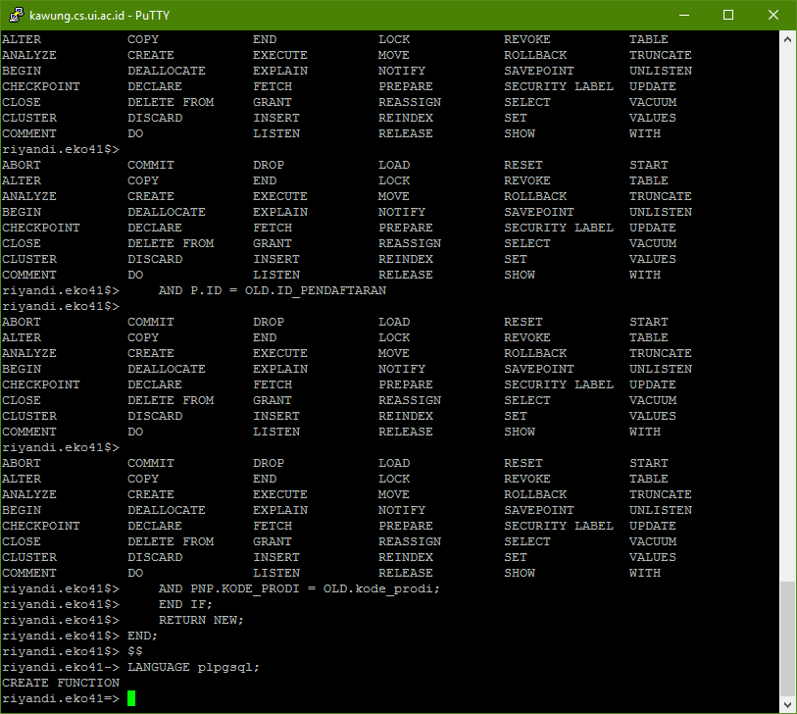

CREATE TRIGGER hitung_pelamar_trigger

AFTER INSERT OR UPDATE OR DELETE

ON PENDAFTARAN_PRODI FOR EACH ROW

EXECUTE PROCEDURE hitung_pelamar();

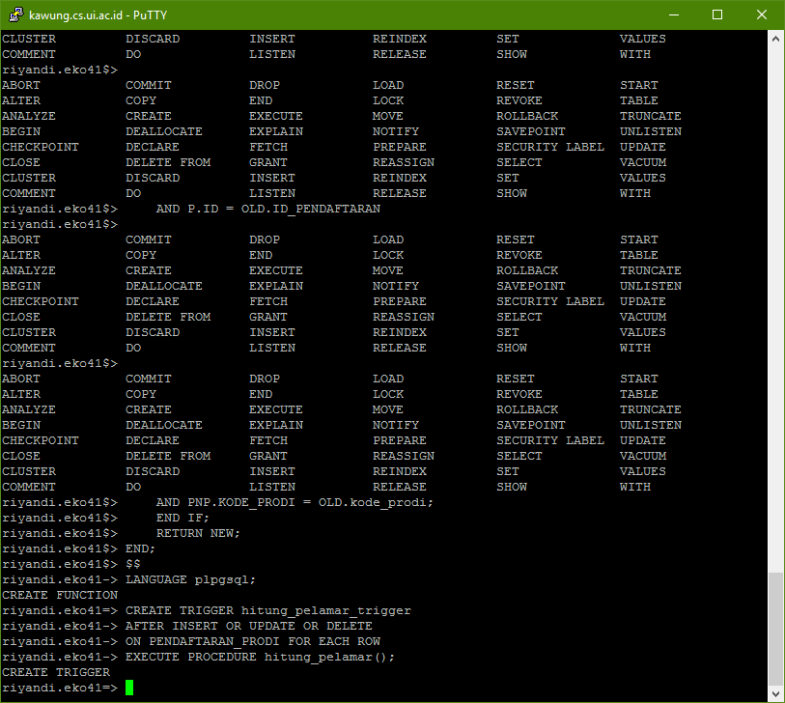

CREATE OR REPLACE FUNCTION hitung_pelamar_diterima()

RETURNS trigger AS

$$

DECLARE

jumlah_lulus INT;

BEGIN

SELECT COUNT(PP.status_lulus) INTO jumlah_lulus

FROM PENDAFTARAN_PRODI PP

WHERE PP.ID_PENDAFTARAN = NEW.ID_PENDAFTARAN

AND PP.status_lulus = TRUE;

IF (TG_OP = 'UPDATE') THEN

IF(NEW.status_lulus IS TRUE AND OLD.status_lulus IS FALSE) THEN

IF(jumlah_lulus = 1) THEN

UPDATE PENERIMAAN_PRODI PNP

SET jumlah_diterima = (coalesce(jumlah_diterima,0) + 1)

FROM PERIODE_PENERIMAAN PRP

JOIN PENDAFTARAN P

ON P.NOMOR_PERIODE = PRP.NOMOR

AND P.TAHUN_PERIODE = PRP.TAHUN

WHERE PRP.NOMOR = PNP.NOMOR_PERIODE

AND PRP.TAHUN = PNP.TAHUN_PERIODE

AND P.ID = NEW.ID_PENDAFTARAN

AND PNP.KODE_PRODI = NEW.kode_prodi;

ELSE

RAISE EXCEPTION 'Error : status_lulus untuk id_pendaftaran yang sama maksimal berjumlah 1';

END IF;

ELSEIF(NEW.status_lulus IS FALSE AND OLD.status_lulus IS TRUE) THEN

UPDATE PENERIMAAN_PRODI PNP

SET jumlah_diterima = (jumlah_diterima - 1)

FROM PERIODE_PENERIMAAN PRP

JOIN PENDAFTARAN P

ON P.NOMOR_PERIODE = PRP.NOMOR

AND P.TAHUN_PERIODE = PRP.TAHUN

WHERE PRP.NOMOR = PNP.NOMOR_PERIODE

AND PRP.TAHUN = PNP.TAHUN_PERIODE

AND P.ID = NEW.ID_PENDAFTARAN

AND PNP.KODE_PRODI = NEW.kode_prodi;

END IF;

END IF;

RETURN NEW;

END;

$$

LANGUAGE plpgsql;

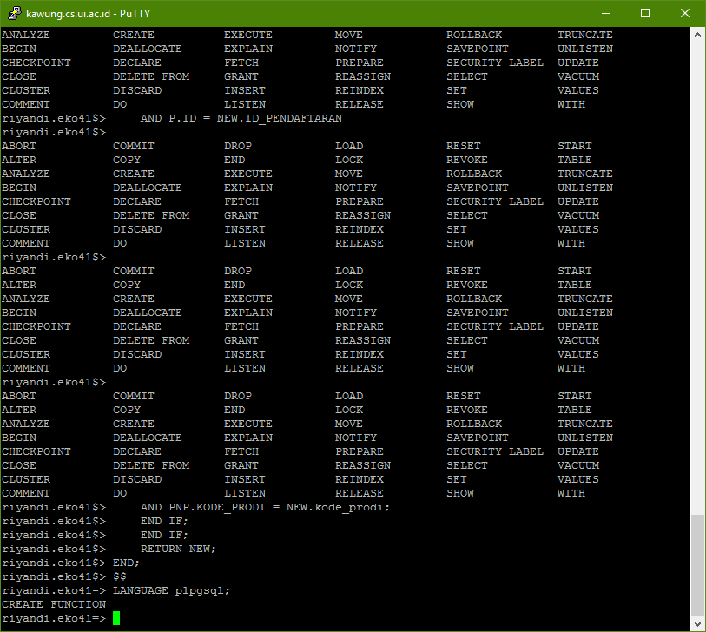

CREATE TRIGGER hitung_pelamar_diterima_trigger

AFTER UPDATE of status_lulus

ON PENDAFTARAN_PRODI FOR EACH ROW

EXECUTE PROCEDURE hitung_pelamar_diterima();

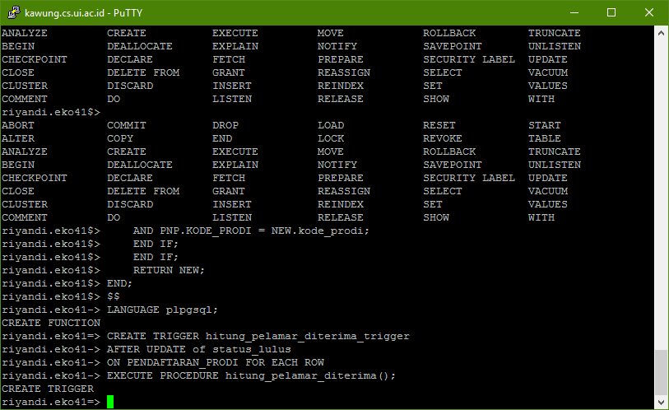

1. **Table state**

\d AKUN

\d JADWAL_PENTING

\d JENJANG

\d LOKASI_UJIAN

\d PELAMAR

\d PEMBAYARAN

\d PENDAFTARAN

\d PENDAFTARAN_PRODI

\d PENDAFTARAN_SEMAS

\d PENDAFTARAN_SEMAS_PASCASARJANA

\d PENDAFTARAN_SEMAS_SARJANA

\d PENDAFTARAN_UUI

\d PENERIMAAN_PRODI

\d PENGAWAS

\d PERIODE_PENERIMAAN

\d PROGRAM_STUDI

\d REKOMENDASI

\d RUANG_UJIAN

1. **Pembagian tugas dan kontribusi**

|  |  |  |  |
| --- | --- | --- | --- |
| **NPM** | **Nama** | **Deskripsi Tugas** | **Kontribusi** |
| 1606954735 | Arri Kurniawan | Membuat script DDL untuk create table, stored procedure dan trigger | 25% |
| 1606954754 | Budi Indrawan | Membuat script DDL untuk insert query dan program untuk generate data acak (9 table) | 25% |
| 1606954792 | Fadly Muhammad Ridho | Membuat script DDL untuk insert query dan program untuk generate data acak (9 table) | 25% |
| 1406649403 | Riyandi Eko Pambudi | Menyusun laporan akhir, melakukan koreksi query serta eksekusi script DDL ke dalam sistem | 25% |